Project Report
1. PROJECT TITLE
VidyaMitra: The Intelligent Career Agent – AI-Powered Resume Evaluator, Trainer & Career Planner
VidyaMitra is an AI-based career assistance platform designed to help students and job seekers improve their employability. The system analyzes resumes, identifies skill gaps, and provides personalized recommendations for skill development, interview preparation, and career planning.
It acts as a virtual career mentor by offering resume evaluation, learning suggestions, mock interview practice, and career progress tracking. The goal is to bridge the gap between academic learning and industry requirements.

2. PROJECT DESCRIPTION
● System Overview
Vidyamitra is an AI-powered career guidance system that helps users improve their resumes, identify skill gaps, practice interviews, and plan career growth. The system analyzes resumes using AI models and provides suggestions for improvement, training recommendations, and interview preparation.
● Problem Domain
Many students and job seekers struggle with:
- Poor resume formatting
- Lack of ATS-optimized keywords
- Missing industry-required skills
- Limited interview preparation
Vidyamitra solves these problems by providing automated AI-based career guidance.
● Core Technology Used
Frontend Technologies:
- HTML
- Tailwind CSS
- Vite
- JavaScript
Backend Technologies:
- Python
- FastAPI / API-based backend architecture
Database / Cloud:
- Supabase
Other Technologies:
- AI model APIs
- REST APIs
- Environment configuration using .env
● Key Capabilities
- AI-based resume analysis
- Skill gap detection
- ATS keyword optimization
- Interview question generation
- Career path suggestions
- Training and learning recommendations
● Target Users
- College students preparing for placements
- Final-year students entering the job market
- Fresh graduates
- Job seekers improving resumes and interview skills
- Training institutes
● Real-world Relevance
Modern hiring systems rely heavily on automated resume screening tools. Vidyamitra helps candidates optimize their resumes and develop relevant skills to improve employability and interview success.

3. APPLICATION SCENARIOS / USE CASES
Educational Usage
Students preparing for campus placements can analyze their resumes and receive suggestions to improve job readiness.
End-user Usage
Job seekers can upload resumes, identify missing skills, and receive interview preparation guidance.
Enterprise Usage
HR teams can integrate the system to automatically analyze candidate resumes and shortlist suitable applicants.
Industrial Usage
Training institutes can use the platform to guide students in developing industry-relevant skills.

4. TECHNICAL ARCHITECTURE OVERVIEW
● High-level Architecture Diagram
User
│
Frontend (HTML + Tailwind + Vite)
│
Backend API (Python)
│
AI Resume Analysis Engine
│
Supabase Database
│
Results Returned to Frontend
● Component Interaction Diagram
Main components include:
User Interface
│
Frontend Application
│
Backend API (main.py)
│
┌───────────────┐
│ AI Model APIs |
└───────────────┘
│
Supabase Database
│
Response Sent to User
● Data / Request Flow
- User opens the Vidyamitra web interface.
- User uploads a resume file.
- Frontend sends the resume to the backend API.
- Backend processes the request.
- AI model analyzes the resume.
- Skill gaps and recommendations are generated.
- Results are returned to the frontend.
- User receives feedback and improvement suggestions.
- Analysis displayed on dashboard

System Layers Explanation
Frontend Layer
Responsible for user interaction and displaying results.
Key files:
- index.html
- src/
- tailwind.config.js
- vite.config.js
Features:
- Resume upload interface
- Result display dashboard
- User interaction interface
Backend Layer
Handles system logic and AI processing.
Important files:
- main.py
- check_supabase.py
- diagnose_keys.py
- list_models.py
Responsibilities:
- API request processing
- Resume analysis
- AI model integration
- Database interaction
Database Layer
Supabase cloud database stores:
- User data
- Resume analysis records
- Skill recommendations
External APIs
- AI model APIs
- Supabase cloud database
Deployment Environment
- Web-based system
- Node.js frontend server
- Python backend server

5. PREREQUISITES
5.1 Software Requirements
Development Tools
- Python 3.x
- Node.js
- npm
IDE
- Visual Studio Code
Runtime Environment
- Python interpreter
- Node.js runtime
Cloud Services
- Supabase
5.2 Libraries / Frameworks / Dependencies
Backend:
- fastapi
- python-dotenv
- supabase
- requests
Frontend:
- vite
- tailwindcss
- postcss
Other Dependencies:
- Node modules
- Environment configuration tools

5.3 Hardware Requirements
Minimum system requirements:
- 8GB RAM
- Intel i5 processor or higher
- Internet connection
- 10GB storage

6. PRIOR KNOWLEDGE REQUIRED
Programming Languages
- Python
- JavaScript
- HTML and CSS
Framework Basics
- Web development fundamentals
- REST APIs
Database Fundamentals
- Basic database concepts
- Cloud databases
Networking / Cloud Concepts
- API communication
AI / ML Fundamentals
- Natural Language Processing basics
- AI model integration

7. PROJECT OBJECTIVES
Technical Objectives
Develop an AI-powered system capable of analyzing resumes and recommending improvements.

Performance Objectives
Ensure fast processing and accurate suggestions.

Deployment Objectives
Create a scalable web-based career guidance platform.

Learning Outcomes
- Full-stack web development
- AI integration in applications
- API development
- Cloud database integration

8. SYSTEM WORKFLOW
Step-by-step execution:
- User opens the Vidyamitra platform.
- User uploads a resume file.
- Frontend sends the file to backend API.
- Backend processes resume data.
- AI engine analyzes content.
- Skill gaps and suggestions are generated.
- Results are displayed on the frontend.

9. MILESTONE 1: REQUIREMENT ANALYSIS & SYSTEM DESIGN
9.1 Problem Definition
Job seekers face difficulties creating optimized resumes and identifying required skills for job roles.
9.2 Functional Requirements
The system should:
- Accept resume uploads
- Analyze resume content
- Detect skill gaps
- Provide interview questions
- Suggest learning resources
9.3 Non-Functional Requirements
- Fast response time
- Secure data storage
- Scalable architecture
- High system availability
9.4 System Design Decisions
- Web-based application
- API-driven backend
- Cloud database
- AI-powered resume analysis
9.5 Technology Stack Selection
Layer | Technology
Frontend | HTML, Tailwind, Vite
Backend | Python
Database | Supabase
AI | AI model APIs

10. MILESTONE 2: ENVIRONMENT SETUP & INITIAL CONFIGURATION
10.1 Development Environment Setup
Install:
- Python
- Node.js
- VS Code

10.2 Dependency Installation
Backend dependencies
pip install -r requirements.txt
Frontend dependencies
npm install

10.3 Project Structure Creation
Project Folder Structure
vidyamitra/
│
├── backend/
│
├── frontend/
│
├── .env
│
└── README.md
10.4 Configuration Setup
The configuration of the VidyaMitra system is managed using the .env file, which stores important environment variables such as API keys, database connections, and other system settings. This helps keep sensitive information secure and separate from the main code.
Configuration Files:
- backend/ – Contains server-side logic and AI processing modules.
- frontend/ – Contains the user interface of the application.
- .env – Stores environment variables and configuration settings.
- README.md – Provides project documentation and setup instructions.

11. MILESTONE 3: CORE SYSTEM DEVELOPMENT
Feature 1 – Resume Analyzer
Description
Analyzes resumes to identify missing skills and formatting issues.
Code Logic
- Upload resume
- Extract text
- Analyze keywords
- Generate feedback
Output
- Resume score
- Improvement suggestions

Feature 2 – Skill Gap Detection
The system compares resume skills with industry requirements and recommends missing skills.

Feature 3 – Mock Interview Generator
The system generates technical and HR interview questions based on user skills.

API Endpoints
Example endpoints:
POST /upload_resume
GET /analyze_resume
GET /skill_suggestions

12. MILESTONE 4: INTEGRATION & OPTIMIZATION
Component Integration
Frontend connected with backend APIs.

Performance Optimization
- Faster API processing
- Efficient data handling

Security Enhancements
- Environment variables for API keys
- Secure API requests

Error Handling
- Invalid resume format detection
- Server error management

13. MILESTONE 5: TESTING & VALIDATION

Test Cases
Test Case ID | Input | Expected Output | Status
TC1 | Upload resume | Resume analyzed | Pass
TC2 | Missing skills | Skill suggestions | Pass
TC3 | Interview generator | Questions generated | Pass

Unit Testing

Individual backend functions tested.

Integration Testing

Frontend and backend communication verified.

User Acceptance Testing

Students tested system usability and feedback quality.

Performance Metrics

Response time:
2–4 seconds per analysis

Load Handling:
Supports multiple users simultaneously

Security Validation:
API keys secured using environment variables

14. DEPLOYMENT

Deployment Architecture

User Browser
│
Frontend Server
│
Backend Python API
│
AI Model Service
│
Supabase Database

Hosting Platform

Possible platforms:
- Vercel (frontend)
- Render / Railway (backend)

Deployment Steps
- Deploy frontend build
- Deploy backend API
- Configure environment variables
- Connect Supabase database

Production Considerations
- Secure API keys
- Scalable server infrastructure
- Database backup strategy

15. PROJECT STRUCTURE

project_root

│

├── backend

│ ├── __pycache__

│ ├── data

│ ├── middleware

│ ├── routes

│ ├── services

│ ├── .env

│ ├── check_supabase.py

│ ├── diagnose_keys.py

│ ├── list_models.py

│ ├── main.py

│ └── requirements.txt

│

├── frontend

│ ├── node_modules

│ ├── public

│ ├── src

│ ├── .env

│ ├── index.html

│ ├── package.json

│ ├── postcss.config.js

│ ├── tailwind.config.js

│ └── vite.config.js

│

├── AI_SETUP_GUIDE.md

├── README.md

├── start-backend.bat

└── TODO.md

Folder Explanation

backend
Contains backend API logic and AI integration.

frontend
Contains UI code and web interface.

routes
Handles API endpoints.

services
Contains business logic and AI functions.

middleware
Handles request processing and authentication.

data
Stores processing data or models.

16. RESULTS

System Output:
- Resume evaluation report
- Skill recommendations
- Interview practice questions

Performance:
- Fast response time
- Accurate suggestions

Screenshots:
- Resume upload interface
- Analysis result dashboard

17. ADVANTAGES & LIMITATIONS

Advantages
- Automated resume analysis
- Personalized career guidance
- AI-powered recommendations
- Time-saving for job seekers

Limitations
- AI accuracy depends on training data
- Requires internet connection
- Limited job role dataset

18. FUTURE ENHANCEMENTS
- Mobile application development
- Advanced AI career prediction
- LinkedIn integration
- Job portal integration
- Automated resume builder
- Real-time interview simulator

19. CONCLUSION

The Vidyamitra system demonstrates how artificial intelligence can enhance career guidance by analyzing resumes and identifying skill gaps. The platform integrates frontend, backend, AI models, and cloud databases to provide intelligent recommendations for job seekers. This project highlights the practical application of AI and full-stack development in solving real-world career preparation challenges.

20. APPENDIX

Source Code/Github Repo:

https://github.com/gandhisiddhi81/Vidya_Mitra_Career_Devlopment_Platform

Output Images

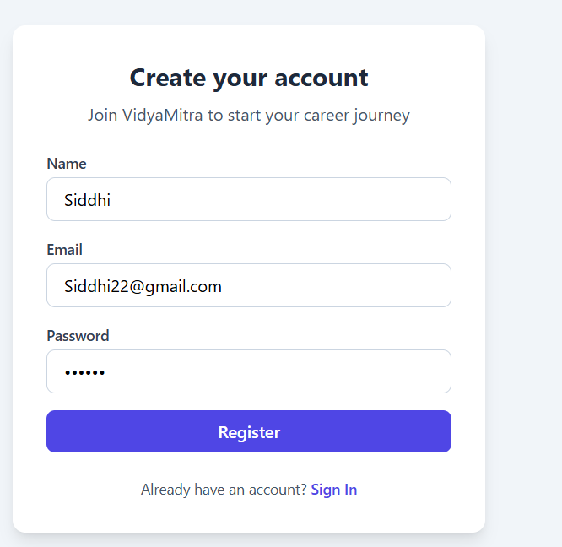

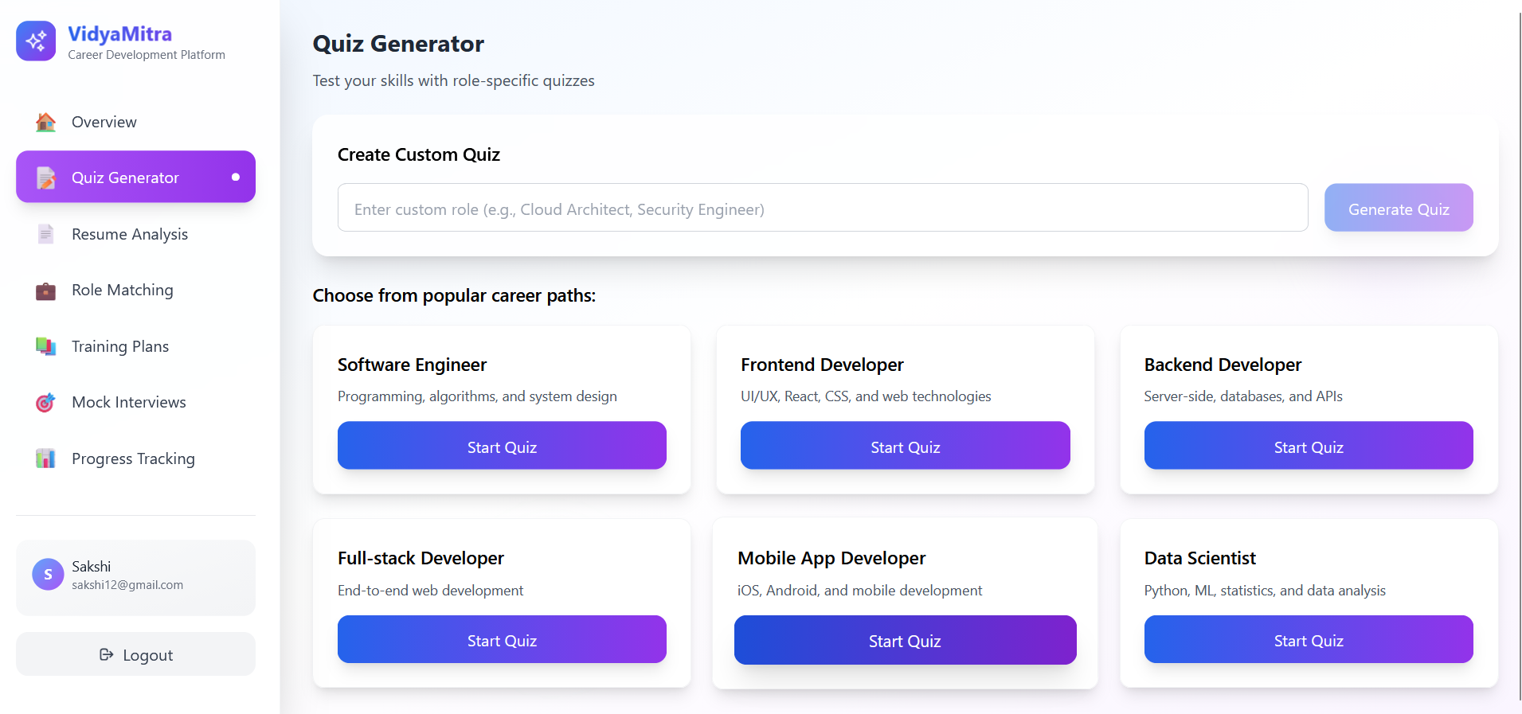

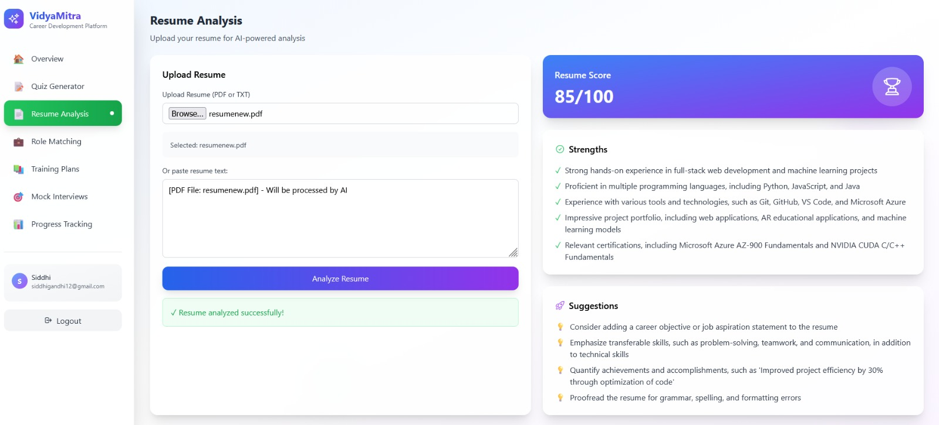

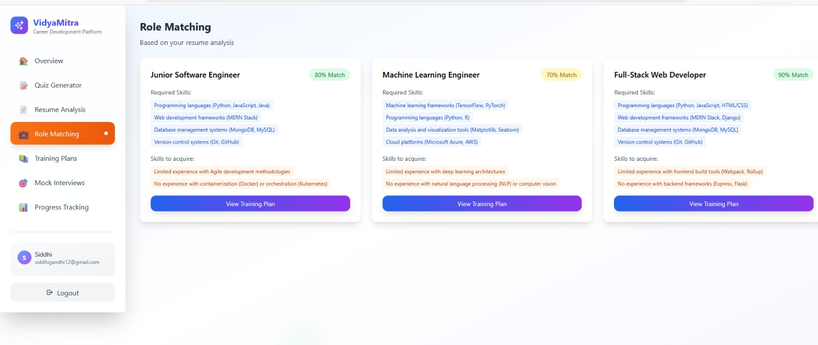

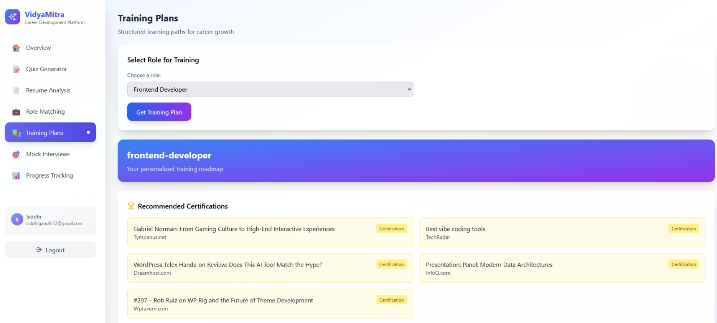

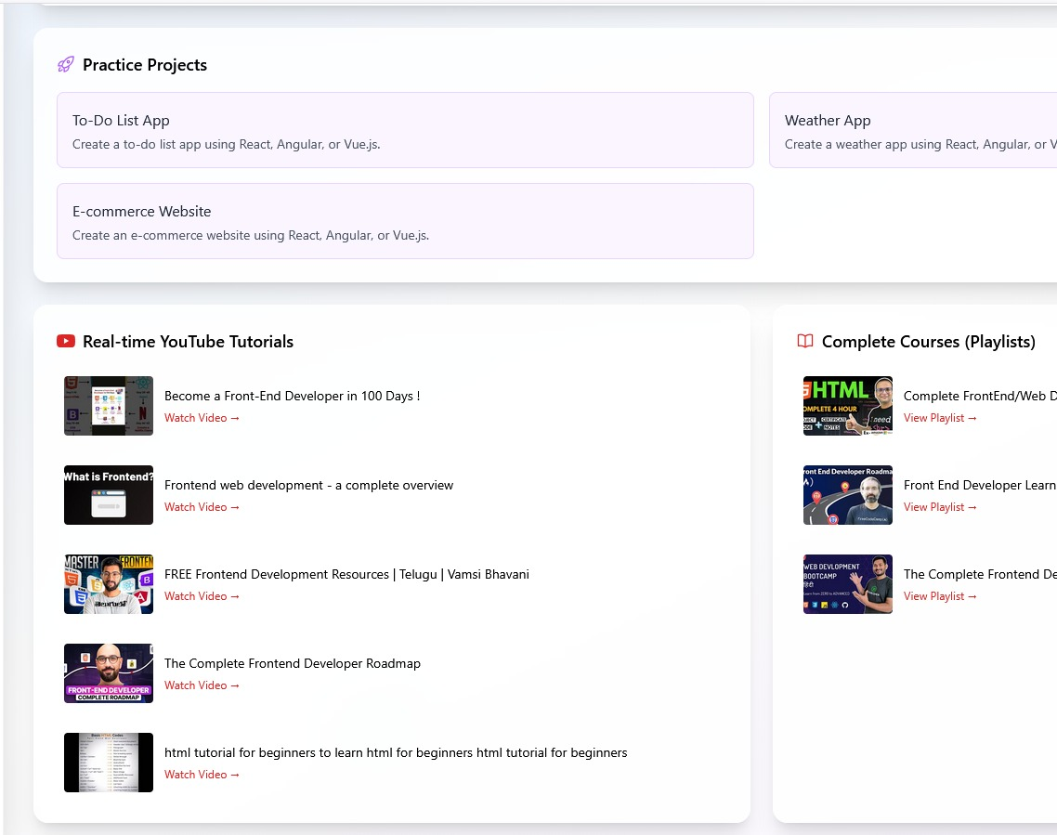

Video Link: https://drive.google.com/file/d/1OEHVHIaxQRvlejxBMEep-NoVp2EP9mwj/view?usp=drive_link

Render Deployment Link:(prefer video link most…sometimes deployment is stuck because everyting uses supabase and supabase become sometimes unhealthy cause it is banned in india

https://vidya-mitra-career-devlopment-platform-r457.onrender.com

